SIMATS ENGINEERING

ASSESSMENT TOOL 2

COURSE NAME:Computer Networks COURSE CODE: CSA0713

COURSE OUTCOME COVERED

CO1: Apply the functions of OSI layer in enabling reliable data transmission across networks. (BL2, BL3)
Assessment Tool Weightage: 30%

Annexure A

CONCEPT MAPPING

Code of Conduct:

I A sreenath(192525119) certify that this submission is my original work and that I have adhered to the guidelines specified for this assessment.
I understand that any violation of academic integrity rules will result in disciplinary action.

Signature of the student: A sreenath

CONCEPT MAPPING
1. A partially completed concept map is given below:
Application → Presentation → ______ → Transport → Network → ______ → Physical.
Analyze the missing layers and explain how their functions are essential for reliable
communication.
Sol..
- Application → Presentation → Session → Transport → Network → Data Link → Physical
🧩 Missing Layers
- Session Layer (between Presentation and Transport)
  - Function: Manages sessions (dialogues) between applications. It establishes, maintains, and terminates communication sessions.
  - Importance: Ensures that data streams are properly synchronized and organized, especially in long-running communications (e.g., video calls, file transfers). Without it, applications might lose track of ongoing conversations.
- Data Link Layer (between Network and Physical)
  - Function: Provides reliable node-to-node data transfer. It handles error detection/correction, framing, and flow control.
  - Importance: Ensures that data sent over the physical medium (like cables or wireless signals) is free from transmission errors. Without it, raw bits could be corrupted or lost, making communication unreliable.

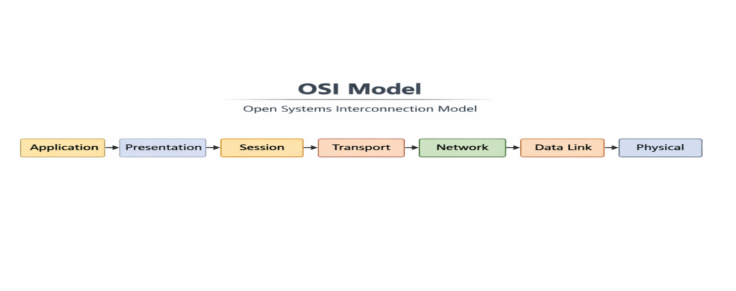
2. Construct a concept map linking data units (Segment, Packet, Frame, Bits) with
their respective OSI layers and analyze how transformation of data units supports
transmission.
Sol..
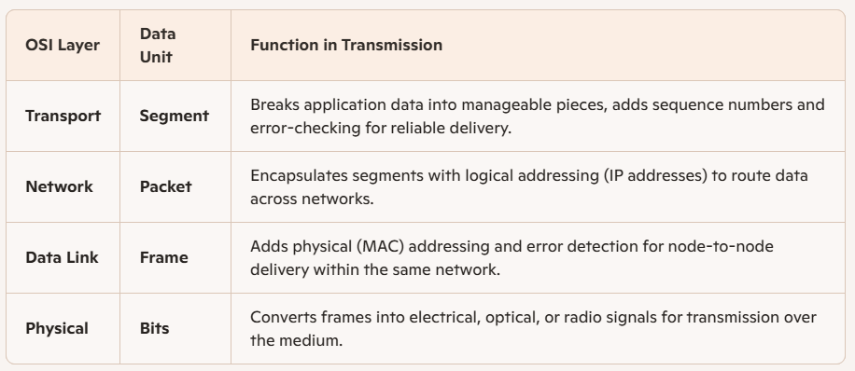
• Segmentation (Transport Layer)
- Divides large data streams into smaller, ordered segments.
- Ensures reliable delivery through acknowledgments and retransmissions.
• Packetization (Network Layer)
- Adds source and destination IP addresses.
- Enables routing across multiple networks, ensuring data reaches the correct endpoint.
• Framing (Data Link Layer)
- Wraps packets with MAC addresses and error-check codes.
- Guarantees that data moves correctly between devices on the same local network.
• Bit Conversion (Physical Layer)
- Translates frames into raw bits (0s and 1s).
- Sends them as electrical pulses, light waves, or radio signals through cables or air.

3.Given the concept map:
DataLink→MACAddress→LocalDelivery
Network → IP Address → Global Delivery
Explain how these relationships ensure complete data delivery across networks.
Sol..
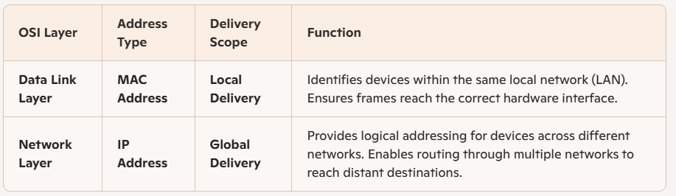

- Local Delivery (Data Link Layer)
  - The MAC address is a unique hardware identifier assigned to each network interface card (NIC).
  - It ensures that data frames are delivered accurately within the same network segment — for example, from one computer to another connected to the same router or switch.
  - This layer handles error detection and frame synchronization, ensuring reliable node-to-node communication.
- Global Delivery (Network Layer)
  - The IP address provides a logical identifier that can change depending on the network.
  - It enables routing — the process of finding the best path across interconnected networks (LANs, WANs, Internet).
  - Routers use IP addresses to forward packets from one network to another until they reach the destination device.
- Combined Operation
  - When data travels across networks, it moves from global addressing (IP) to local addressing (MAC) at each hop.
  - Routers strip and rebuild frames with new MAC addresses while keeping the IP address constant, ensuring that data moves seamlessly from source to destination.
  - This layered cooperation guarantees end-to-end delivery — from the sender’s application down to the receiver’s hardware.

4. A concept map shows:
ErrorControl
→DataLinkLayer→ErrorDetection
→ Transport Layer → Error Correction
Analyze how the interaction between these layers improves reliability in data
transmission.
Sol..
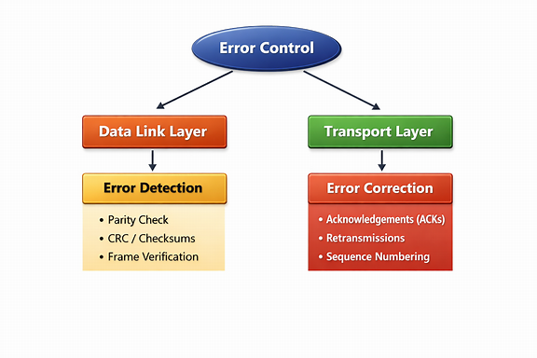
• Data Link Layer → Error Detection
- Uses mechanisms like checksums, CRC (Cyclic Redundancy Check), and parity bits.
- Detects errors that occur during transmission across a single physical link (e.g., corrupted frames due to noise or interference).
- If an error is detected, the frame may be discarded or a retransmission requested.
• Transport Layer → Error Correction
- Ensures end-to-end reliability across the entire communication path.
- Uses techniques like acknowledgments (ACKs), retransmissions, and sequence numbering.
- Corrects errors by resending lost or corrupted segments, ensuring complete and ordered delivery to the application.

5. Develop a concept map for web browsing using OSI layers and analyze how
failure in one layer affects the entire communication process.
Sol..
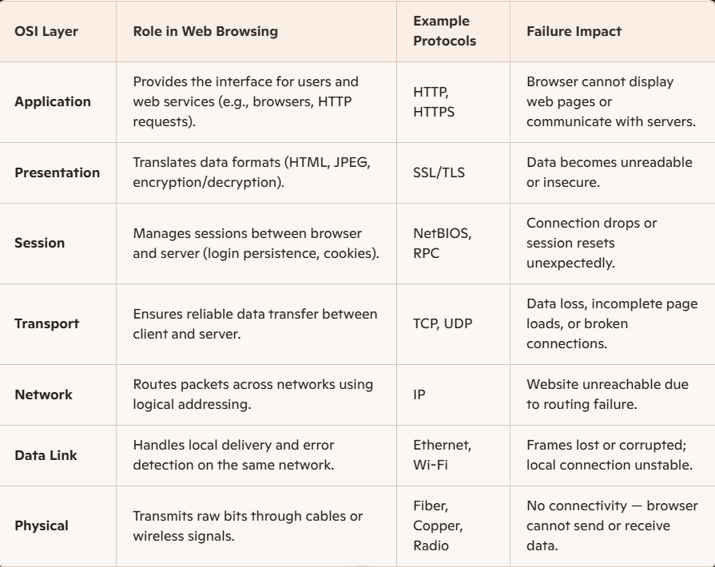
• Top-Down Dependency
- Each layer depends on the one below it. For example, HTTP (Application Layer) relies on TCP (Transport Layer) to deliver data reliably.
• Failure Cascade
- A failure at any layer breaks the chain:
  - If the Physical Layer fails (e.g., cable unplugged), all higher layers lose connectivity.
  - If the Network Layer fails (e.g., IP misconfiguration), routing stops, and the browser cannot reach the server.
  - If the Transport Layer fails, packets may be lost, causing incomplete page loads.
  - If the Application Layer fails, even though data arrives, the browser cannot interpret or display it.
• Reliability Through Cooperation
- The layers work together to ensure that web browsing is seamless — from electrical signals to readable web content.
- Each layer adds its own form of control (error checking, addressing, encryption) to maintain integrity and security.

6. A network issue is represented in the concept map:
Physical ✔ → Data Link ✔ → Network ✖ → Transport ✖ → Application ✖
Analyze the problem and explain how the concept map helps in troubleshooting.
Sol..
Physical ✔ → Data Link ✔ → Network ✖ → Transport ✖ → Application ✖
This means:
- Physical Layer: ✅ Working — cables, signals, and hardware are functioning.
- Data Link Layer: ✅ Working — local communication (MAC addressing, frame delivery) is successful.
- Network Layer: ❌ Failing — routing or IP addressing issues prevent packets from reaching other networks.
- Transport Layer: ❌ Failing — since the network layer is down, segments cannot be delivered end-to-end.
- Application Layer: ❌ Failing — web pages, emails, or apps cannot communicate because lower layers are broken.
